

MATCH YOUR HAIR COLOR
8 Color Options for Toppik, Couvre & Fullmore Products

COLOR CHART
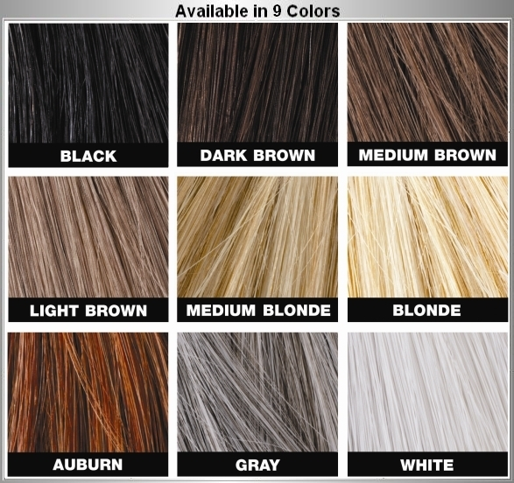

TIPS FOR MIXING AND MATCHING COLORS

Many people’s hair contains multiple shades of color like those with “salt and pepper” hair. If you fit into this category, try combining two different shades of toppik for a more customized match. Simply apply the lighter color first, and then follow with the darker one. You’ll be amazed at the results. And remember if the color you order doesn’t match your hair color to your satisfaction; you can always return it and try a different color. That’s what our 100% RISK FREE TRIAL GUARANTEE is all about.
TEL. 800-416-3325 www.toppik.com SPENCER FORREST

